Vortex Quake 2 Quick-Start Guide
By GHz (ghz@project-vortex.com)
Last updated 10/6/2009

Game Overview

Vortex is a modification of Quake 2, a game published by Id Software. The first publicly playable version of Vortex was released sometime in 1999, and has maintained a cult-following thanks to continuous updates and improvements. It is a first-person shooter (FPS) with role-playing game (RPG) elements.

The core element is character development. Players fight and kill each other in order to gain experience points. After a certain number of points are accumulated, your character will gain a level. When this happens, you are allotted ability and weapon points which can be used to upgrade skills (abilities) or weapons. Some abilities are passive, meaning you don’t have to do anything to benefit from them, while others are active and require typing a command (or binding a key to the command) to activate.

With over 100 ability and weapon upgrades to choose from, there are plenty of combinations possible to differentiate one character from another. While some games lock abilities to certain classes, Vortex allows any class to upgrade any ability. The classes do, however, allow specialization. Each class has abilities that can be upgraded higher than non-class abilities. Finally, talent upgrades reward players who reach high levels, making them even stronger.

This document is by no means comprehensive. For the most up-to-date information, you should visit our website and message board:

http://www.project-vortex.com (main site)
http://project-vortex.com/forums (message board)
http://www.moddb.com/mods/project-vortex (moddb page)

Rules

Although server administrators may impose additional rules, these are the basic ones that you should know to avoid getting kicked or banned from the server, or having your character file deleted. They are rather obvious, but should be stated for completeness:

- No cheats or hacks are allowed. This includes aimbots, wallhacks, speedhacks, and anything that gives you an unfair advantage over other players. Although we do our best to detect and block these, sometimes they get through. If you’ve found a hack that works, report it the administration.
- Do not abuse game exploits. Sometimes a bug is discovered that might allow you to gain extra experience, better items, or make it easier to kill your opponents. If a bug is discovered, please report it immediately to Vortex’s administration. Do not use it to your advantage, even if everyone else is. You put yourself in danger of being penalized later.
- Do not access someone else’s character unless they give you express permission to do so, even if they neglect to set a password. This is considered character stealing and is not permitted.
- Do not gain experience points, credits, or items that you didn’t earn. The most common offense of this kind is dummy killing, whereby players kill one another without fighting. Another example is capturing the flag in CTF without opposition (e.g. the teams agree to capture each other’s flag without fighting). This is a serious offense and usually gets your character deleted (or worse).
- Do not disobey game or server administrators. If they tell you to do something, do it. If you suspect abuse or otherwise don’t agree, you can take it up with me (see my email address above).

Getting Started

Follow the steps below to get started playing Vortex Quake 2.

IMPORTANT: If you downloaded the full Vortex installer, you won’t have to manually configure your controls from the console or Quake 2 menu screen. The Vortex Game Launcher (VGL) will make this easier by providing a familiar Windows user interface. Please see the document “Using The Vortex Game Launcher” included in your installation directory for further instruction, and skip to step 4.

- Choose a name

When you first start Quake 2, you will be presented with the console. It is the text interface for the game; you may access it anytime by pressing the tilde (‘~’) key.

The first step is to choose what name (or, “handle”) you want to be known as. To do this, use the ‘name’ command. At the console, type: ‘name <your name>’. If you have would like to use a space in your name, you will need to encase it in quotation marks. For example, to call yourself Captain America, you would type: name “Captain America”

** Note: Your name becomes your character. If you want to come back to your character at another time, you will need to choose the same name. You can’t change names after your character is already created, so choose wisely.

- Set a password

To prevent unauthorized use of your character, you should set a password. To do so, type: set vrx_password <password> u. Example: set vrx_password mypass123 u

You should save this in a config file, otherwise you will have to enter it each time you join the server. To do this, just open up Wordpad or Notepad, enter the above command with your password, and save it in a config file (e.g. vortex_config.cfg) in either the baseq2 or vortex subdirectory. Then all you have to do is type ‘exec vortex_config.cfg’ when you’re ready to play.

- Connect to a server

If you downloaded the full Vortex package (Quake 2 demo + patch + vortex), there should be a file called ‘vortex.exe’. Simply double-click on it to launch the R1Q2 updater, press enter to clear it, and then you will automatically connect to our main server. Otherwise, you can manually connect by typing: connect vrx.dyndns.org:27910

** Note: Be sure that you set your name before connecting to the server. Name changes are not allowed once you’re connected. You will need to reconnect if you want to change your name either using the ‘reconnect’ command or ‘connect vrx.dyndns.org:27910’. Also—as stated above—since your name is your character (essentially a username tied to a character file), if you change names you will be loading a new/different character.
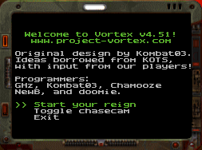
- Join the game

When you first connect to a server, you are placed in spectator mode and presented with a menu asking whether you’d like to “Start your reign” or “Toggle chasecam”. If you select the first option, you’ll join the server immediately unless it’s a special game mode (e.g. CTF) or you this is a new character. If you select the second option, you’ll activate the chasecam. If you accidentally close the menu, you can bring it back again by pressing your Inventory key.

** Note: Vortex’s menus can be navigated using the [ and ] keys. Press ENTER to make a selection. If these keys don’t work, you can bind them yourself (binding keys is discussed below): bind ] invnext; bind [ invprev; bind enter invuse, bind uparrow inven

- Choose a class

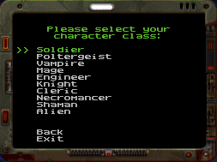
You will be asked to select a class when you first create your character. Here is a brief description:

Soldier – The soldier’s main upgrades are strength and resistance. These are passive abilities that increase attack damage and reduce damage received. If you are used to standard FPS-style deathmatch, it would be wise to upgrade these. Soldiers can also specialize in different kinds of grenades.

Engineer – The engineer is rather weak, and relies on building either traps or other mechanical devices to do his work. Sentry guns are popular, which lay waste to anything coming within their sights.

Knight – The knight is limited to only 1 weapon: the sword. It’s one of the most powerful weapons in the game, but only if you can get close enough to your enemy to use it. Fortunately, knights are incredibly tough and have boost to close distance quickly.

Vampire – The vampire has the innate ability to become invisible while not moving. His main attacks involve stealing life, ammunition, and power cubes from his enemy. Ghost allows the Vampire to repel attacks completely.

Cleric – The cleric is a holy class that relies on auras to boost resistance, heal, and slow targets. Their blessed hammer does devastating damage, but is limited to close range.

Necromancer – The necro can follow two ability trees, either relying on monsters or hellspawn to do his bidding, curses to weaken or confuse his target, or a combination of both.

Poltergeist – The poltergeist is essentially a shapeshifter, capable of becoming a variety of monsters. Each monster has different characteristics, some capable of flying, while others are slow moving behemoths. Fortunately, a poltergeist has every “morph” upgraded to level 1, allowing you to experiment and find one that suits you best.

Mage – As the name implies, the mage has a vast array of spells at his disposal, ranging from flaming meteors that smash enemies to bits, or lightning storms that electrocute unfortunate enough to be near them. The mage is mainly an offensive player; they are relatively weak, and instead rely on their spells to kill quickly before their enemy ever has a chance to react.

Alien – This class was inspired by Gloom, another mod for Quake 2. The alien class can spawn all kinds of biological things, including healers that recover life when you touch them, or spores that will actively chase targets, or gassers that belch a poisonous cloud when an enemy gets too close. They can open a wormhole to quickly navigate a map, even passing through walls.

Shaman – The Shaman’s abilities consist of a variety of totems. These totems are small structures that affect players within its radius. Some totems are beneficial to its owner and allies, while others slow or attack enemies. Haste provided increased attack speed, while fury gives a random boost of strength, resistance, and regeneration.

- Set combat preferences

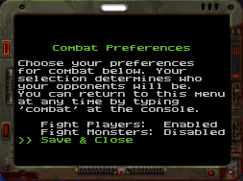
A unique feature of Vortex is that you can choose your enemies. If you are creating a new character, this menu will appear after you have selected a class. At any time during the game, you can bring up this menu again by typing “combat” in the console. From this menu, you can decide if you’d like to fight players or monsters, or any combination of the two. For example, if you’d prefer to fight only monsters (AI-controlled enemies), simply toggle “Fight Players” to Disabled and “Fight Monsters” to Enabled. When you are done, select “Save & Close”.

** Note: These settings only apply to non-team game modes (FFA)

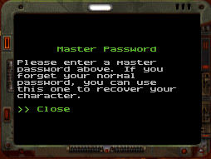
- Set a master password

Sometimes people forget their password. Although it isn’t a requirement, we highly recommend you set a master password (type ‘masterpw’). If you ever forget your normal password, you can use this one to as a back-up to log-in. Once you set a master password, you can’t change it, so be careful when setting it (don’t make it anything obvious; we recommend a combination of letters and numbers).

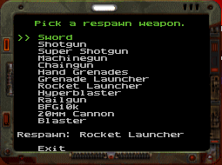
- Choose a respawn weapon

Assuming you have enough respawns (which can be purchased at the armory; see below), you will spawn with the weapon you choose via the ‘vrxrespawn’ menu.

- Vote

If you would like to play a particular map or game mode, use the ‘vote’ command. Select a map and a game mode from the menu to start a vote. Players can then type ‘vote yes’ if they agree with your selection or ‘vote no’ if they do not (if they type nothing, it is an implied no).

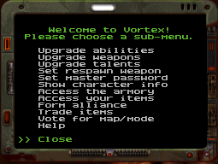
- Access Vortex’s main menu

If you want to set a master password, look at your character stats, access the upgrade menus, set a respawn weapon, or just about anything, you will want to use the ‘vrxmenu’ command. See below for more information about these sub-menus.

Binding Keys

An essential part of FPS games is knowing how to customize your controls. In Quake 2, this is accomplished by using the console to assign commands to keys. For example, let’s say you have an ability called ‘beerme’. You could simply type ‘beerme’ in the console every time you want to use this ability. However, in the heat of battle, this is not practical, so you should bind the command to a key:

bind x beerme

This will cause the x key to be bound to the beerme command. When you press x, the beerme command will be executed. You can put all of your binds in a text file using Wordpad or Notepad, then save the file as myconfig.cfg (replace “myconfig” with an appropriate name of your choice) and put it in your baseq2 folder in your installation directory (e.g. C:\games\Vortex\baseq2) or the vortex sub-directory (e.g. C:\games\Vortex\vortex). Note that if you put the configuration file in the vortex sub-directory, you will be unable to access the file until after you have connected to a server. To load the configuration data into memory, you need to execute it with the ‘exec’ command in the console (e.g. exec myconfig.cfg).

** If you have the Vortex Game Launcher, you don’t need to bind keys manually like this, but it’s a good idea to learn how to anyway!

Secondary Weapon Modes

Many weapons have secondary modes. That means that your weapon may work differently depending on the currently selected mode. For example, the railgun has a normal mode (standard railgun firing) and a sniper mode. In sniper mode, your movement is slowed and you have to charge-up your weapon before you can fire. Once charged, a sniper shot does far more damage than a standard rail shot. Even the trail is invisible.

Bind a key to the togglesecondary command to switch between modes. In some cases, you can even bind keys to these weapon modes. For example, the tank morph has a rocket mode and a punch mode. You can bind a key to each mode for easier switching (bind a use punch; bind b use rocket launcher; bind c use machinegun; bind d use blaster).

Gameplay Modes

Vortex supports a few different game modes. Below is a description of each:

- FFA (Free For All) – This is the default game mode. Players fight and kill each other and/or monsters to gain experience points. Players (and any monsters they may summon) who have set their combat preferences to fight monsters only will glow blue (PvM mode). Morphed players (and any monsters they may summon) who are hostile against other players (i.e. Fight Players is enabled) will glow red (PvP/FFA mode), but non-morphed players will have no color shell. If a PvP/FFA (i.e. a player hostile against other players) player gets more than 5 kills in a row, they will glow or flash green to indicate spree status. If they get more than 24 kills in a row, they (and their minions) glow white to indicate spree war status. You won’t be able to kill anyone except the person (and his minions) during a spree war. Kill them for a big experience bonus!
- CTF (Capture The Flag) – This mode will be familiar to most. There’s a blue team and red team. Players are distributed evenly among the teams by character level. The goal is to capture the enemy flag. You can also claim spawn points for your team which slows down the opposite team’s respawn rate. If you capture all the spawns, then the enemy can only respawn in their own base.
- Invasion – Like PvM, the humans must fight monsters. The difference here is that there is a monster base and a human base. Your goal is to prevent the monsters from invading your base and killing your spawn points. If you win, extra points are awarded based on the number of live player spawns remaining.

Alliances

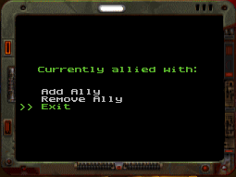
If the server administrator permits it, you can ally with one or more players in PvP and FFA modes. Allied players share experience and can’t hurt each other. Type ‘ally’ at the console to open the allies menu. From here, you can view players you are already allied with, add additional allies, or remove allies.

Upgrades

Ability Upgrades

Each time your character gains a level, you will use the ability upgrade menu. You can access it by typing ‘vrxmenu’ and selecting the appropriate sub-menu, or type ‘upgrade_ability’ at the console.
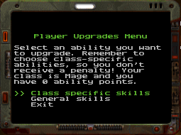
Ability upgrades are divided into 2 categories: Class-specific skills and general skills. Class-specific skills can be upgraded to level 10, while general skills can be upgraded to level 5. Runes (discussed later) can further boost the skill level up to its hard maximum (usually twice the level you can normally upgrade it to). For example, if you upgrade Strength to 10, runes could theoretically boost that to level 20.

When you view your abilities, the upgrade level is displayed on the left, while the effective level is displayed on the right in brackets (after factoring rune bonuses).

Weapon Upgrades
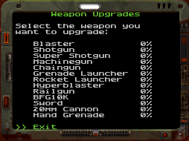
You can upgrade your favorite weapon’s attributes via the weapons upgrade menu. To access it, use ‘vrxmenu’ and select the sub-menu, or use ‘upgrade_weapon’.

Talents

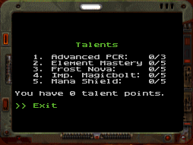
Talent points are accumulated after your character reaches level 10. You can access the talent menu with the ‘talents’ console command or via ‘vrxmenu’. Select a talent to view a brief description and decide if you want to upgrade it.

The Armory

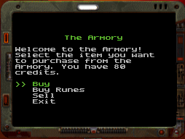
You can access the armory during pre-game time (the first 2 minutes at the start of a map). From this in-game store, you can buy and sell items.

Vortex Game Package

Fortunately for us, Id software made it possible to download and play Quake 2 for free. We have packaged the Quake 2 demo with the latest updates, R1Q2 (game engine enhancements), and Vortex all in one download. Below are some notes specific to this package (if you aren’t using this package, you can skip this section):

Default Controls

Forward – E
Step left – S
Step right – F
Backward – D
Crouch – Z

Attack – Mouse1 (left mouse button)
Jump – Mouse2 (right mouse button)

Inventory – up arrow
Next weapon - >
Previous weapon - <
Next inventory item - ]
Previous inventory item – [
Drop item – backspace
Use item – enter
Show scores/help - Tab

For a complete listing of all Quake 2 console commands, see: http://console.planetquake.gamespy.com/commands/quake_2.html

Default Graphics Configuration

The default graphics mode is R1GL (Open GL) 800 x 600 resolution. Use the video menu to select a different resolution or graphics mode. If your computer does not support OpenGL and has problems with the default configuration, you can delete the config.cfg located in the baseq2 subfolder. This will reset all settings to Id Software defaults (software rendering mode).

Additional Resources

The main Vortex server utilizes R1CH’s anticheat and R1Q2. For more information, see:
http://www.r1ch.net/stuff/r1q2/

Credits & Thanks

Vortex wouldn’t be possible without KOTS, the first Quake 2 modification to show just how much fun an FPS game could be with just a few RPG-like tweaks. We also would like to thank R1CH for his excellent R1Q2/R1GL/anticheat, and also to Team RxN for the Gloom models and sounds we have used.

Owner/Lead Developer:
GHz (ghz@project-vortex.com)

Active Programmers:
Paril (paril@project-vortex.com)
Apple (apple@project-vortex.com)

Inactive Programmers:
Chamooze
Doomie/Archer

Original Design:
Kombat03

Webmaster:
Jordan (jordan@project-vortex.com)

How You Can Help

Vortex is a free game. It costs money to host a server and thousands of hours of development time (programming) to create the content players enjoy. Donations via PayPal are appreciated, but even more helpful is offering to contribute. At the time of this writing (and for most of Vortex’s existence), we’ve been short on development talent. If you’re a graphic/sound artist, programmer, web developer, mapper, or marketer, please contact us.

